**REGULAR EXPRESSION CHECKLIST**

Regular Expressions: Symbols representing a text pattern.

Forward Slashes:

RegexPal: Tool to learn regular expressions. Don’t need to use forward slashes or quotes.

Regex Engines:

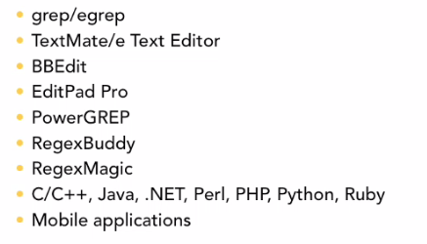

Modes:

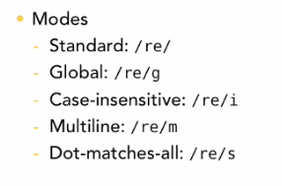

Regex Case-Sensitive: By default.

Global Matching: Match all sets matching in text.

Eagerness: Wanting to return the first match found.

Literal: Exact matches

Meta-Characters: Special characters to determine matches.

Wildcard (.): Can match any character except newline (/h.t/ matches hat, hot, hit, does not match heat, harlot, harriet)

Backslash Escaping: Gives the literal meaning to special characters (ex \.) Literal characters should never be escaped